Animated web code

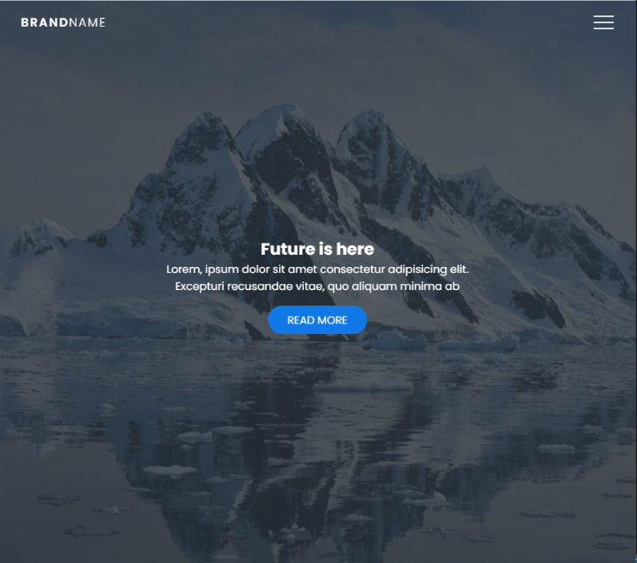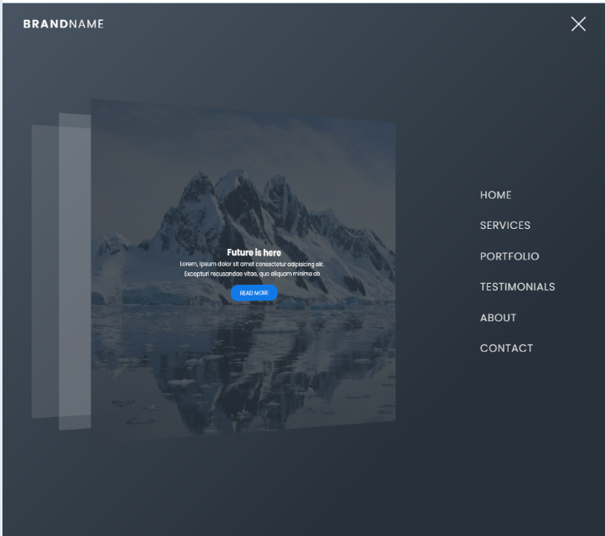

# Js

const hamburger_menu = document.querySelector(".hamburger-menu");

const container = document.querySelector(".container");

hamburger_menu.addEventListener("click", () => {

container.classList.toggle("active");

}

# HTML

<!DOCTYPE html>

<html lang="en">

<head>

<meta charset="UTF-8" />

<meta name="viewport" content="width=device-width, initial-scale=1.0" />

<title>3D Navbar Animation</title>

<link rel="stylesheet" href="style.css" />

</head>

<body>

<div class="container">

<div class="navbar">

<div class="menu">

<h3 class="logo">Brand<span>Name</span></h3>

<div class="hamburger-menu">

<div class="bar"></div>

</div>

</div>

</div>

<div class="main-container">

<div class="main">

<header>

<div class="overlay">

<div class="inner">

<h2 class="title">Future is here</h2>

<p>

Lorem ipsum dolor sit amet consectetur adipisicing elit.

Laudantium illum tenetur consequatur veritatis?

</p>

<button class="btn">Read more</button>

</div>

</div>

</header>

</div>

<div class="shadow one"></div>

<div class="shadow two"></div>

</div>

<div class="links">

<ul>

<li>

<a href="#" style="--i: 0.05s;">Home</a>

</li>

<li>

<a href="#" style="--i: 0.1s;">Services</a>

</li>

<li>

<a href="#" style="--i: 0.15s;">Portfolio</a>

</li>

<li>

<a href="#" style="--i: 0.2s;">Testimonials</a>

</li>

<li>

<a href="#" style="--i: 0.25s;">About</a>

</li>

<li>

<a href="#" style="--i: 0.3s;">Contact</a>

</li>

</ul>

</div>

</div>

<script src="app.js"></script>

</body>

</html>

# CSS

@import url("https://fonts.googleapis.com/css2?family=Poppins:wght@300;400;500;600;700;800;900&display=swap");

* {

padding: 0;

margin: 0;

box-sizing: border-box;

}

body,

button {

font-family: "Poppins", sans-serif;

}

.container {

min-height: 100vh;

width: 100%;

background-color: #485461;

background-image: linear-gradient(135deg, #485461 0%, #28313b 74%);

overflow-x: hidden;

transform-style: preserve-3d;

}

.navbar {

position: fixed;

top: 0;

left: 0;

width: 100%;

z-index: 10;

height: 3rem;

}

.menu {

max-width: 72rem;

width: 100%;

margin: 0 auto;

padding: 0 2rem;

display: flex;

justify-content: space-between;

align-items: center;

color: #fff;

}

.logo {

font-size: 1.1rem;

font-weight: 600;

text-transform: uppercase;

letter-spacing: 2px;

line-height: 4rem;

}

.logo span {

font-weight: 300;

}

.hamburger-menu {

height: 4rem;

width: 3rem;

cursor: pointer;

display: flex;

align-items: center;

justify-content: flex-end;

}

.bar {

width: 1.9rem;

height: 1.5px;

border-radius: 2px;

background-color: #eee;

transition: 0.5s;

position: relative;

}

.bar:before,

.bar:after {

content: "";

position: absolute;

width: inherit;

height: inherit;

background-color: #eee;

transition: 0.5s;

}

.bar:before {

transform: translateY(-9px);

}

.bar:after {

transform: translateY(9px);

}

.main {

position: relative;

width: 100%;

left: 0;

z-index: 5;

overflow: hidden;

transform-origin: left;

transform-style: preserve-3d;

transition: 0.5s;

}

header {

min-height: 100vh;

width: 100%;

background: url("bg.jpg") no-repeat top center / cover;

position: relative;

}

.overlay {

position: absolute;

width: 100%;

height: 100%;

top: 0;

left: 0;

background-color: rgba(43, 51, 59, 0.8);

display: flex;

justify-content: center;

align-items: center;

}

.inner {

max-width: 35rem;

text-align: center;

color: #fff;

padding: 0 2rem;

}

.title {

font-size: 2.7rem;

}

.btn {

margin-top: 1rem;

padding: 0.6rem 1.8rem;

background-color: #1179e7;

border: none;

border-radius: 25px;

color: #fff;

text-transform: uppercase;

cursor: pointer;

text-decoration: none;

}

.container.active .bar {

transform: rotate(360deg);

background-color: transparent;

}

.container.active .bar:before {

transform: translateY(0) rotate(45deg);

}

.container.active .bar:after {

transform: translateY(0) rotate(-45deg);

}

.container.active .main {

animation: main-animation 0.5s ease;

cursor: pointer;

transform: perspective(1300px) rotateY(20deg) translateZ(310px) scale(0.5);

}

@keyframes main-animation {

from {

transform: translate(0);

}

to {

transform: perspective(1300px) rotateY(20deg) translateZ(310px) scale(0.5);

}

}

.links {

position: absolute;

width: 30%;

right: 0;

top: 0;

height: 100vh;

z-index: 2;

display: flex;

justify-content: center;

align-items: center;

}

ul {

list-style: none;

}

.links a {

text-decoration: none;

color: #eee;

padding: 0.7rem 0;

display: inline-block;

font-size: 1rem;

font-weight: 300;

text-transform: uppercase;

letter-spacing: 1px;

transition: 0.3s;

opacity: 0;

transform: translateY(10px);

animation: hide 0.5s forwards ease;

}

.links a:hover {

color: #fff;

}

.container.active .links a {

animation: appear 0.5s forwards ease var(--i);

}

@keyframes appear {

from {

opacity: 0;

transform: translateY(10px);

}

to {

opacity: 1;

transform: translateY(0px);

}

}

@keyframes hide {

from {

opacity: 1;

transform: translateY(0px);

}

to {

opacity: 0;

transform: translateY(10px);

}

}

.shadow {

position: absolute;

width: 100%;

height: 100vh;

top: 0;

left: 0;

transform-style: preserve-3d;

transform-origin: left;

transition: 0.5s;

background-color: white;

}

.shadow.one {

z-index: -1;

opacity: 0.15;

}

.shadow.two {

z-index: -2;

opacity: 0.1;

}

.container.active .shadow.one {

animation: shadow-one 0.6s ease-out;

transform: perspective(1300px) rotateY(20deg) translateZ(215px) scale(0.5);

}

@keyframes shadow-one {

0% {

transform: translate(0);

}

5% {

transform: perspective(1300px) rotateY(20deg) translateZ(310px) scale(0.5);

}

100% {

transform: perspective(1300px) rotateY(20deg) translateZ(215px) scale(0.5);

}

}

.container.active .shadow.two {

animation: shadow-two 0.6s ease-out;

transform: perspective(1300px) rotateY(20deg) translateZ(120px) scale(0.5);

}

@keyframes shadow-two {

0% {

transform: translate(0);

}

20% {

transform: perspective(1300px) rotateY(20deg) translateZ(310px) scale(0.5);

}

100% {

transform: perspective(1300px) rotateY(20deg) translateZ(120px) scale(0.5);

}

}

.container.active .main:hover + .shadow.one {

transform: perspective(1300px) rotateY(20deg) translateZ(230px) scale(0.5);

}

.container.active .main:hover {

transform: perspective(1300px) rotateY(20deg) translateZ(340px) scale(0.5);

}